Over the last year, the trustees of Ealing Mencap have been working on a new long term plan for the charity, taking into account all challenges that we face to continue to deliver real value for the people we care about and their families.



Ealing Mencap Enterprise Lodge Stockdove Way Greenford, UB6 8TJ

020 8566 9575

[info@ealingmencap.org.uk](mailto:info@ealingmencap.org.uk) [www.ealingmencap.org.uk](http://www.ealingmencap.org.uk/)

We have already made a number of changes including the recruitment of some excellent new trustees and setting up a parents support service to work with some of the most severely challenged families. Both Lesley Dodd and I have decided that the time is right to step down as Chair and Chief Executive respectively. We will of course be working hard between now and the end of the year to ensure a smooth transition.

Working with Kyte Lester Appointments, the Executive Search Consultancy specialising in the Not-for-Profit sector, the Board is therefore pleased to announce the appointments of Rory Hegarty as Chair and Nik Demetriades as Chief Executive Officer.

Rory Hegarty will be taking over as Chair from September 2023 and brings over 20 years of experience in leading communications and public engagement for high profile bodies in the NHS.

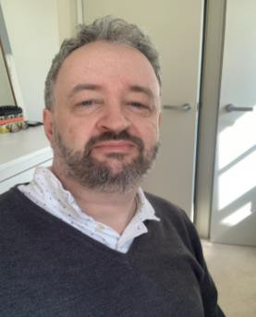

Nik Demetriades will be taking over from our retiring CEO on 1st November 2023. His background as a Chief Executive Officer of three disability not-for-profit organisations since 2005 has given Nik 18 years of experience of successfully leading charities through a challenging process of development, innovation and change.

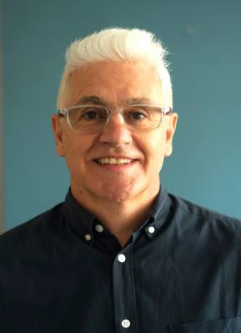

This is an exciting time for Ealing Mencap as both Rory and Nik work closely together to build on the legacy and modernise, reshape, support, strengthen and grow the work of our amazing long-standing charity.

Please join me in warmly welcoming Rory and Nik and wishing them both well for the future.

George Venus Chair

